GUI and CLI

GUL is graphical user interface and GUI is a type of interface that allows users to interact with electronic devices through icons and visual indicators such as secondary notation, as opposed to text-based interfaces, typed command labels or text navigation.

The GUI is different to the CLI because the GUI it allows a user to interact with a computer by using a keyboard and mouse and by seeing images on the screen of things your tapping about or looking up.

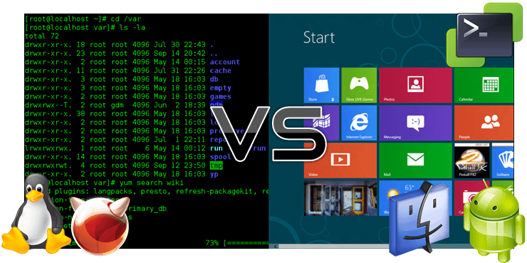

A CLI is command line interface is a user interface to a computer's operating system or an application in which the user responds to a visual prompt by typing in a command on a specified line, receives a response back from the system, and then enters another command, and so forth.

The CLI is different to the GUI because the CLI is allow user to tap text commands into a terminal window which means you will not be able to see images and uses things like google.